GEOGRAPHY OF CHINA VIDEO FOLLOW ALONG
Directions: Use the link on the class website www.wms6thgradesocialstudies.weebly.com to watch and fill in the answers. Use CC to help you with spelling. Use your laptop to pause or rewind as you watch. Be ready to discuss with the class.
https://www.youtube.com/watch?v=J6IrkUvJxio

Location Matters:
- Two important factors limited China’s contact with outsiders

- The _________________________________________________ forms part of China’s natural border to the West.

*Geography Quiz: What is a plateau?

- The ________________________________________________contain some of the tallest mountains in the world.

*Geography Quiz: What mountain peak is shown in the picture? ___________________

- The _______________________________________________ is a vast area stretching from Mongolia into China.

*Geography Fact: A desert is an area which receives less than ___________ inches of rain per year. That means the largest desert in the world is ____________________________!

NATURAL BARRIERS:
- What formed China’s natural barrier to the East? _______________________________________________
- All four physical features make a natural ____________________________________________
BONUS! How does this impact China? [List 2] ______________________ ________________________

- How did geography influence China’s development? FILL IN THE CHART BELOW!
HELP | HURT

- FIX THIS STATEMENT → Circle the word that makes it FALSE & CHANGE the word:
Long distances prevented all trade between China and other ancient civilizations.

RIVERS OF CHINA:
- Two Main Rivers of China:
Name of River: |  | Also Called:
Name of River: |  | Also Called:

- FLOODS!!! What did they bring? _______________________________________________
*Geography Quiz: What is another civilization that flourished along the banks of a river that flooded frequently? ____________________________________________

- What is the ominous (gloomy) nickname of the The Huang He River? __________________________________
DIVE DEEPER!
- Why does it have this nickname? _______________________________________________
- Why do people still live near the river? _______________________________________________

- Use the word bank below to write the correct name of the physical feature on the line.
Word Bank: Tibetan Plateau, Himalayan Mountains, Pacific Ocean, Gobi Desert

PICTURE | NAME OF PHYSICAL FEATURE
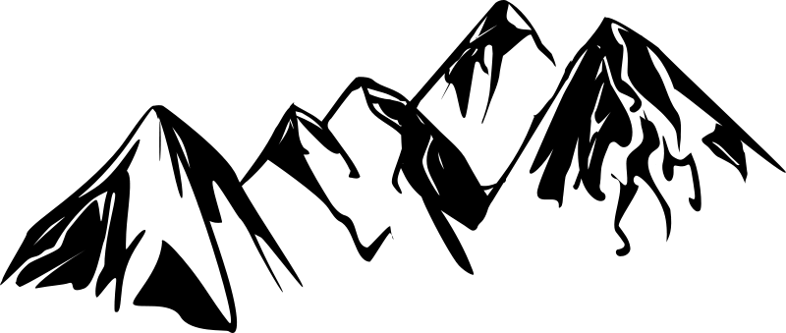
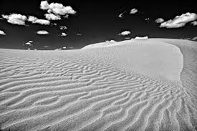
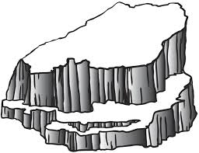
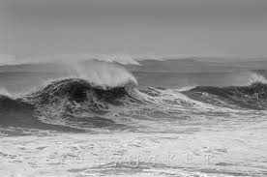
FOLD & GLUE

