Ancient Mesopotamia Map Skills
PART #1 DIRECTIONS: Follow each step below to label the map in color. Make sure you check off each box as you complete it.
- Step #1: Trace the Tigris River, Euphrates River, & Persian Gulf [BLUE]
- Step #2: Highlight Babylonia, Sumer, and Assyria [PURPLE]
- Step #3: Trace a box around the 2 mountain ranges names [BROWN]
- Step #4: Trace a box around the 2 deserts names [YELLOW]
- Step #5: Label the area between the rivers MESOPOTAMIA & Color/Shade [GREEN]
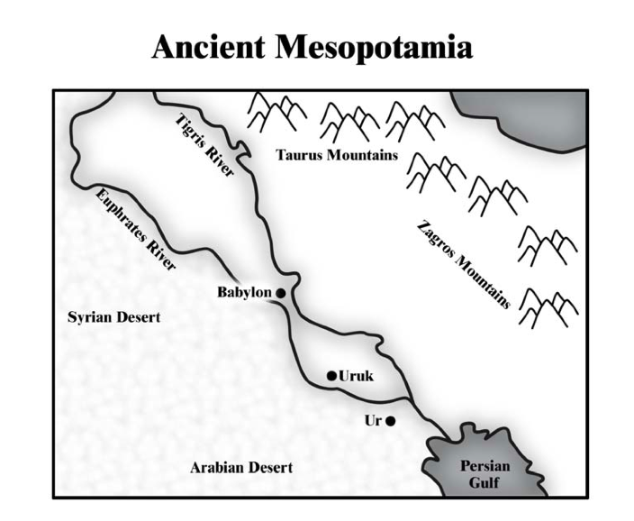
Sumer

Sumer

Assyria

PART #2 DIRECTIONS Fill in the chart with each physical feature in Mesopotamia [river, mountain, desert, or sea] to explain how they made the Fertile Crescent a perfect location to develop a civilization. Add this information to the map next to the physical feature.
Physical Feature Name | How Did It Help Development Of Mesopotamia?
- Arabian & Syrian Desert | - Protected them from invasion of other civilizations
- Persian Gulf
- Taurus & Zagros Mountains
- Euphrates & Tigris Rivers

Ancient Mesopotamia Geography Reading
PART #3 DIRECTIONS: As you read, highlight and use academic conversations to create ANNOTATIONS. Then, switch with your team and have them add their annotations as well. Each team member needs to select a different color to annotate with or write their initials by their annotations.

ACADEMIC CONVERSATION FOCUS:  CLARIFY & ELABORATE  WHEN YOU ARE DISCUSSING THE READING WITH YOUR TEAM, KEEP FOCUSED AND USE THE CONVERSATION STARTERS TO HELP GUIDE YOUR DISCUSSION! | - I think it means…  - It’s similar to…  - To be clear, you’re saying that…  - I’m confused when you say ____, Can you elaborate?  - So you’re saying that…  - I hear you saying that…  - In the text it said…  - An illustration of this…  - An example is…  - According to…  - Building On  - Another way to look at this could be…  - Yes–and I would add..  - Adding to what ______ said,…  - Overall, what I’m trying to say is…  - My whole point in one sentence is…  - The evidence suggests that…

Mesopotamia is a Greek word meaning 'between the rivers'. The rivers are the Tigris and Euphrates which flow through modern Iraq. The Euphrates also flows through much of Syria. Mesopotamia is made up of different regions, each with its own geography. The geography of each area and the natural resources found there affected the ways that people lived.

Northern Mesopotamia is made up of hills and plains. The land is quite fertile due to seasonal rains, and the rivers and streams flowing from the mountains. Early settlers farmed the land and used timber, metals and stone from the mountains nearby.

Southern Mesopotamia is made up of marshy areas and wide, flat, barren plains. Cities developed along the rivers which flow through the region. Early settlers had to irrigate the land along the banks of the rivers in order for their crops to grow. Since they did not have many natural resources, contact with neighboring lands was important.
FOLD & GLUE

