Elements of Culture Video Follow Along Questions

Directions: Use this link to watch and fill in the answers.https://youtu.be/jt2tikGSu98 Use your chromebook to pause or rewind as you watch. Be ready to discuss with the class!

Elements of Culture:
- Culture is a huge topic of study for Sociologist. Culture exist anywhere ________________ exist. No ______________ cultures are the same.
- Combinations of elements together form _______________________ unique way of life.

We will take a closer look at those elements: Symbols, Language, ___________________, and Norms. These elements look different across cultures and change over__________________________ as a society evolves.

Symbols: anything that is used to _______________________ for something else
- People who share a culture often attach meaning to an ___________________, gesture, sound, or image.
  - For example: _________________________ is a significant symbol to Christians
- American Culture:
  - Emoticons are combination of keyboard characters that many use to represent their_________________________ online or texting
- American Flag:
  - represents our entire _____________________________
- Red Light:
  - Relays the message that you need to _________________ your vehicle

Language: is a system of ____________________ and symbols used to communicate with other people
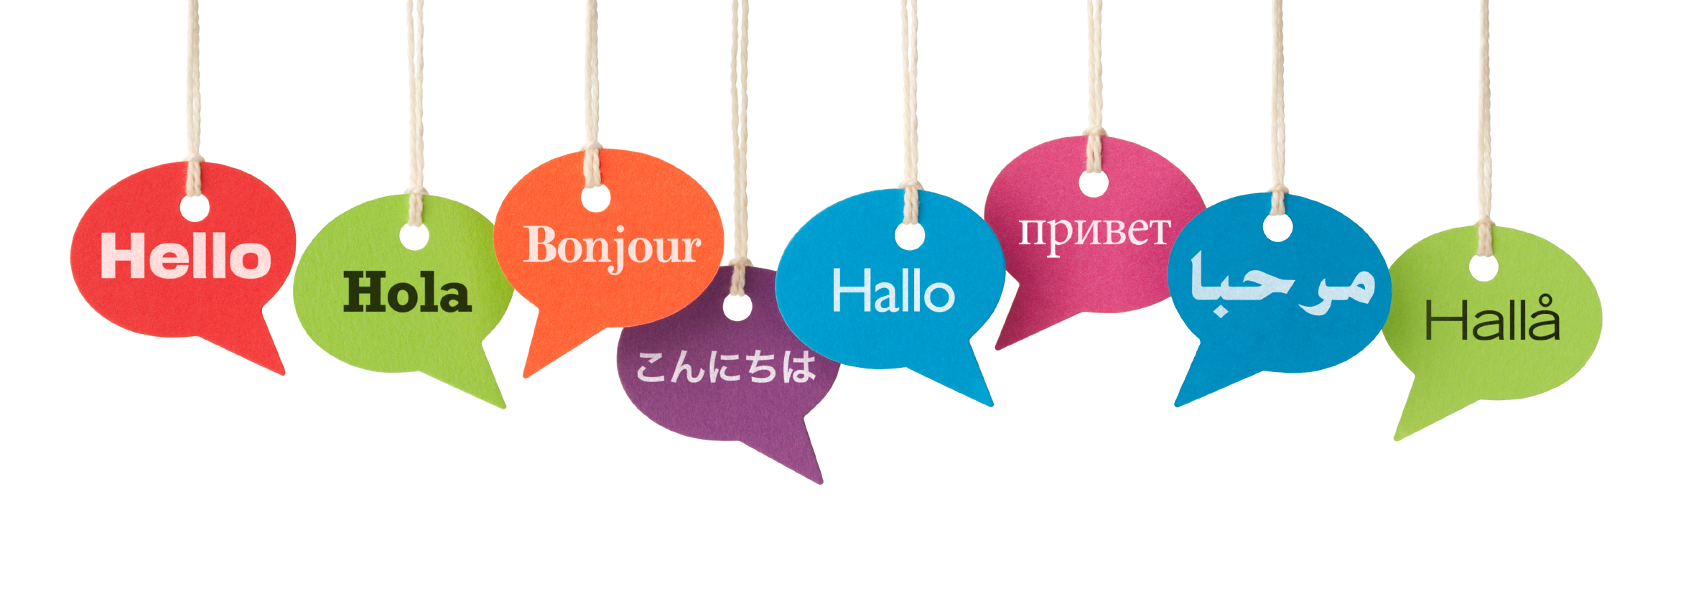
- This includes full languages as we usually think of them, such as English, Spanish, French, etc.
  - Also includes __________________ language, slang, and common __________________________ that are unique to certain groups of people.
    - For example: even though English is spoken fluently in both America and Britain, we have ________________________ and phrases that mean different things.
      - American= French fries
      - British= ________________
      - American= Cookies
      - British= Biscuits
  - Another example of how cultural languages differ beyond vocabulary is the fact that__________________ contact represents different meanings in different cultures.
      - America = eye contact suggests that you are ______________ attention and are interested in what a person has to say.
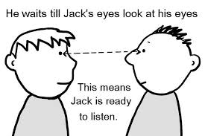
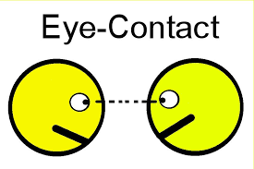
      - Other cultures =eye contact may be considered ________________ and to be a challenge of authority.

Values: which are culturally defined standards for what is ___________________________ or desirable
- Members of the culture use the shared system of values to decide what is ______________ and what is ___________________________.
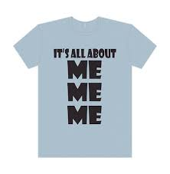
  - America, we are individualistic - we encourage competition and emphasize personal achievement.
      - A person who accepts a promotion in our culture is praised for their individual ______________________work and talent.
  - Collectivistic values of other cultures, where collaboration is encouraged, and a person's success is only as good as their contributions to the _______________________.
      - The same person that is offered a promotion who lives in a collectivistic culture would consult with his ___________________ before accepting to ensure that it would be the most beneficial to the group as a whole.

Norms: culturally defined expectation of _____________________________
- They are guidelines we use to determine how to __________________________in any given situation and what would be considered inappropriate behavior.
  - Example: we know that we should stand in line to use the_________________ without even thinking about our behavior if someone cuts in front of us we are certainly irritated if not angry that the other person has not followed the norms of our culture.
- vary in their perceived importance and in the way that others react in their violation. Some norms are turned in a formal rules and ________________ while others are unwritten.
  - Folkways: norms that dictate appropriate behavior for routine or casual interaction.
    - Example: Don’t pick your nose in public
  - Mores: norms that dictate morally right or wrong behavior. These are rules for behavior that are so important that they usually don't even get written down because they go without saying.
    - Example: Using profanity at a funeral

Summary Directions: Pick ONE of the options below to reflect about the information presented in the video. Make sure to use your notes to help you create your summary.

Picture Summary:  Create a collage of pictures for the different parts [elements] of cultures you learned about. Draw 5 pictures and label them with the element of culture. Pictures must be colored. | Writing Summary:  How would you describe culture to someone who doesn’t know anything about it? Think about the different elements of culture that you learned and write in 5 complete sentences.
Fold and Glue

