Mesopotamian Culture

What Was Life Like in Sumer?
While Sumerian kings lived in large palaces, ordinary people lived in small mud-brick houses. Most people in Sumer farmed. Some, however, were artisans, or skilled workers who made metal products, cloth, or pottery. Other people in Sumer worked as merchants or traders. They traveled to other cities and towns and traded tools, wheat, and barley for copper, tin, and timber – things that Sumer did not have.
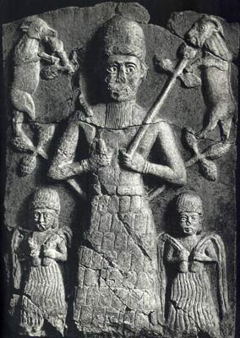
People in Sumer were divided into three social classes. The upper class included kings, priests, and government oficals. In the middle class were artisans, merchants, farmers and fishers. These people made up the largest group. The lower class were enslaved people who worked on farms or in temples.
Enslaved people were forced to serve others. Slaveholders thought of them as property. Some slaves were prisoners of war. Others were criminals. Still others were enslaved because they had to pay off their debts.

Gender Roles
In Sumer, women and men had separate roles. Men headed the households. Only males could go to school. Women, however, did have civil rights. They could buy and sell property and run businesses.
The Sumerians left a lasting mark on world history. Their ideas and inventions were copied and improved upon by other peoples. As a result, Mesopotamia has been called the “cradle of civilization.”

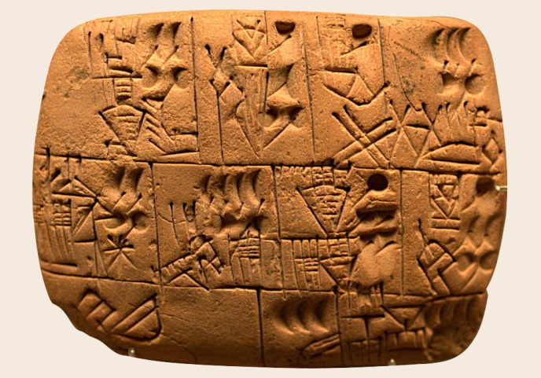
Why Was Writing Important?
The people of Sumer created many things that still affect our lives today. Probably their greatest invention was writing. Writing is important because it helps people keep records and pass on their ideas to others.
People in Sumer developed writing to keep track of business deals and other events. Their writing was called cuneiform. It consisted of hundreds of wedge-shaped marks cut into damp clay tablets with a sharp-ended reed. Archaeologists have found thousands of these cuneiform tablets, telling us much about Mesopotamian life.
Only a few people – mostly boys from wealthy families – learned how to write. After years of training, they became scribes, or record keepers. Scribes held honored positions in society, often going on to become judges and political leaders.

