Geography of the Fertile Crescent

The Land Between the Rivers

The ancient Greeks called the region between the Tigris and the Euphrates Mesopotamia. In Greek, Mesopotamia means “Land Between the Rivers.”

Downhill to the Sea
Both the Tigris and Euphrates rivers begin in the Taurus Mountains of what is today Turkey. They continue to the plateau of present-day northern Iraq. In southern Iraq, the rivers flow across lower land to the Persian Gulf. The rivers deposit silt as they flow south, making the region a good place for farming. Silt is loose soil carried by water.
Farmers in southern Mesopotamia had to protect their fields from flooding each fall. During spring and summer, they needed water for their crops in the hot, dry climate .This region got only a few sprinkles of rain each year. Droughts, or long periods without rain, were a constant threat.
Northern Mesopotamia, in contrast, usually had enough rain to make some farming possible. Yet the earth of the northern plateau was mostly rocky and bad for farming.

Exploring Technology
Levees and Canals
The Tigris and Euphrates often burst into fields in the fall, as crops were about to be harvested. These floods destroyed crops, as well as lives and homes. Mesopotamian farmers found ways to control flooding.
Flood Control – To protect against floods, farmers built a system of levees to keep the waters back. A levee is a wall that keeps a river within its banks.
Irrigation – A system of canals to bring water to crops and fields is called irrigation. Mesopotamian farmers brought water from artificial lakes to irrigate their crops.
How did the Mesopotamians use technology to control their water supply?

Successful Farmers
As you read in the lesson on Catal Huyuk, the first known agriculture began in western Asia about 8,500 years ago. The area’s environment supported many wild plants, such as wheat and barley, which could be domesticated as crops. Animals, such as cattle, sheep, and pigs, were also found wild there.
Over time early Mesopotamian farmers learned how to grow many different crops. If you were able to go back in time, you would see fields of wheat and barley. These were the region’s most important crops. You would also see gardens of beans, onions, lettuce, cucumbers, and herbs. Ancient farmers also grew date palm, apple, and pomegranate trees. Because crops and trees need lots of water, farmers often planted them along canal banks. There are few trees in the region today, but in ancient times large forests stretched from the Mediteranean Sea to the Persian Gulf.

Using the Environment
Over time, people cut the trees for buildings or firewood. Tree roots hold soil in place, so much of the fertile soil dried up and blew away. The wearing away of soil by wind or water is called erosion. As a result, much of modern Mesopotamia is a desert due to erosion.
On the edges of farmland, you might have seen shepherds herding sheep and goats for their milk and wool. Anceint Mesopotamians also valued cattle. Cattle were work animals, and produced milk and meat. Herders guarded against wild animals. Lions were once common in this region, but today there are no lions in the Fertile Crescent. Why might this be true?
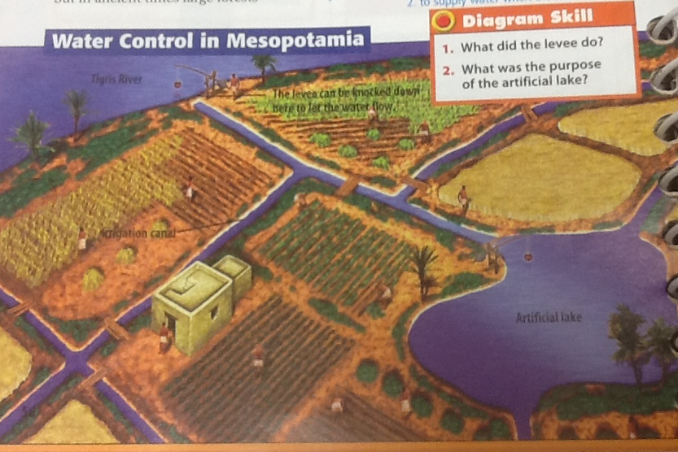
Putting This Together

Two great rivers, the Tigris and the Euphrates, influenced the environment of Mesopotamia. These rivers made it possible for farmers to raise surplus crops and to develop some of history’s early cultures. Ancient Mesopotamians built irrigation canals.
In time, Mesopotamian farmers began producing more food than they could for themselves. Not everyone had to be a farmer anymore. Some people became soldiers, scholars, and leaders. Villages grew into cities as the Mesopotamians established a civilization.

