Unit 10 Geography of China River Valley: Map Skills

Pre-test: _________%  Level [circle]: N/A [0-79] or P/E [80-100] | Post-test: _________%  Level [circle]: N/A [0-79] or P/E [80-100]

Part #1: Labeling the Map
Directions: Use the steps below to color code the map of Ancient China.
- Check off the task as you complete each step.
- Step #1: Fill in the compass on the map below with INTERMEDIATE DIRECTIONS.
- Step #2:Trace the HUANG HE [YELLOW RIVER] and CHANG JIANG RIVER [YANGTZE] [BLUE]
- Step #3: Draw a triangle around the GOBI & TAKLIMAKAN DESERT [YELLOW]
- Step #4: Circle the name of the THE PLATEAU OF TIBET [ORANGE]
- Step #5: Draw triangles on the HIMALAYAN MOUNTAIN RANGE [BROWN]
- Step #6: Trace a box around the YELLOW SEA & PACIFIC OCEAN [BLUE]
- Step #7: Trace the GREAT WALL OF CHINA [RED]
- Step #8: Color the area on either side of the HUANG HE RIVER [GREEN] to show that the area was fertile from the river’s irrigation of the farmland.
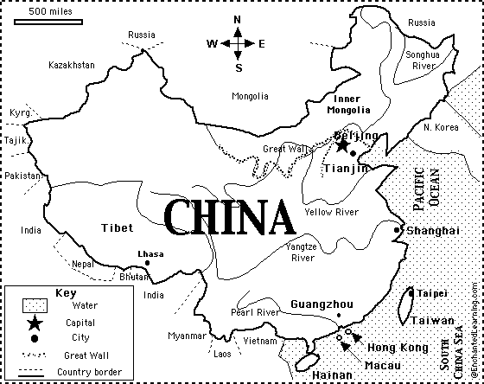
Taklimakan Desert
TAKLIMAKAN DESERT
HIMALAYA
Himalaya Mountains
Yellow Sea
PLATEAU OF
TAKLIMAKAN
Yellow Sea
HIMALAYA MOUNTAIN RANGE
Gobi Desert
Plateau of

Part #2: Physical Features Impact on china
Directions: Use the chart to explain how each physical feature made China River Valley a perfect location to develop a civilization.
- Use the annotations from your map to help you fill in the chart
Physical Feature Name | IMPACT: POSITIVE | IMPACT: NEGATIVE
- The Gobi & Taklimakan Desert | - Protected them from invasion | - ISOLATION & MADE TRADE DIFFICULT IN NORTHERN CHINA
- Yellow Sea & Pacific Ocean
- The Huang He/Yellow & Chang Jiang/Yangtze River
- The Himalayan Mountains

Part #3: Isolation and Protection of the China River Valley
Directions: Check off as you complete each step.
- 1st: Read the paragraph and highlight key ideas with your team
- 2nd: discuss what big ideas you should annotate for each paragraph
- 3rd. Use the information to fill in the chart about the impact that physical features have on the development and success of a civilization.
ANNOTATIONS | DESERTS of China Impact & Impact on the Civilization  Ancient China was bordered by two of the world’s largest deserts: the Gobi Desert to the north and northwest and the Taklamakan Desert to the west. These two deserts were a natural defense helping to protect China from outside invaders, but they also limited Chinese expansion. Rulers could not invade other lands across the desert. This restrained the size of China’s empire.
ANNOTATIONS | MOUNTAINS of China & Impact on the Civilization  Asia is home to several vast mountain ranges. Several of these mountain ranges surrounded ancient China. These mountains provided them with protection from invaders. This kept the Chinese from expanding their civilization even farther southwest. Just as the Himalayan Mountains kept the Chinese from expanding southward, they also kept the Indus River Valley from expanding into China.

What 2 civilizations were isolated & protected by their physical features?  - _____________  - _____________ | What physical features ISOLATE & PROTECT a civilization from others?  - ____________  - ____________ | What is the impact of being BOTH isolated and protected?  Positive: ____________  Negative: ____________
Fold & Glue Tab

