Geography of Indus River Valley: Map Skills
Part #1: Labeling the Map
Directions: Use the steps below to color code the map of Ancient India.
- Check off the task as you complete each step.
- Step #1: Fill in the compass on the map below with INTERMEDIATE DIRECTIONS.
- Step #2:Trace the INDUS and GANGES RIVERS [BLUE]
- Step #3:Trace around the PENINSULA OF INDIA [YELLOW]
- Step #4: Draw a triangle around the THAR DESERT [YELLOW]
- Step #5: Circle the name of the DECCAN PLATEAU [ORANGE]
- Step #6: Draw triangles on the HIMALAYAN MOUNTAIN RANGE [BROWN]
- Step #7: Trace a box around the ARABIAN SEA, BAY OF BENGAL, & INDIAN OCEAN names [BLUE]
- Step #8: Color the area on either side of the INDUS RIVER [GREEN] to show that the area was fertile from the river’s irrigation of the farmland.
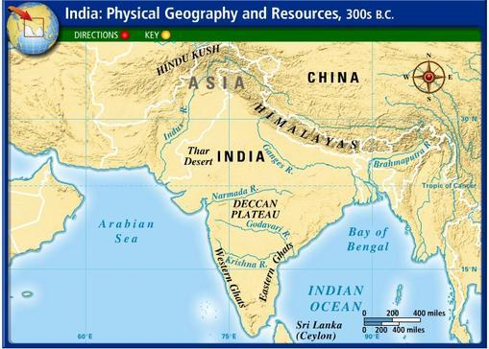

Part #2: PHYSICAL FEATURES IMPACT ON INDIA CHART
Directions: Fill in the chart to explain how they made the Indus River Valley a perfect location to develop a civilization.
- Add this information to the map next to the physical feature.
Physical Feature Name | How Did It Help Development Of The Indus River Valley Civilization?
- Thar Desert
- Arabian Sea & Indian Ocean
- The Indus & Ganges River
- The Himalayan Mountains

Part #3: Isolation and Protection of the Indus Valley
Directions: Check off as your complete each step.
- 1st: Read the paragraph below and annotate & talk to the text with your TEAM!
- 2nd: As you fill in the chart, think about how the Indus Valley was more INDEPENDENT and ISOLATED from other civilizations. Consider the POSITIVE AND NEGATIVE effects of this
Water and mountains surrounded ancient India. This geographic isolation protected the people who settled in this region. It was extremely difficult for outside invaders to reach the subcontinent without making dangerous journeys over the mountains or across the ocean.
Isolation Provided By:  - ____________  - ____________ | 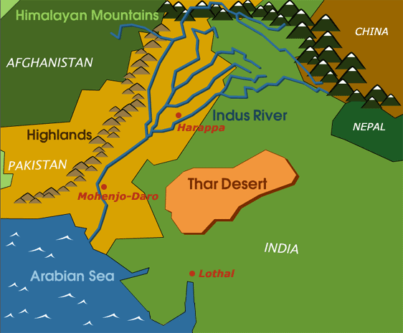 | Protection Provided By:  - ____________  - ____________
Benefits to Isolation  [+] | Negative Effects of Isolation  Being separated from other civilizations | Benefits to Protection  [+]
Fold & Glue Tab

