GEOGRAPHY OF ANCIENT ROME MAP SKILLS

Pre-test: _________% Level: N/A [0-79] or P/E [80-100] | Post-test: _________% Level: N/A [0-79] or P/E [80-100]

Part #1: Labeling the Map
Directions: Use the steps below to color code the map of Ancient Greece
- Check off the task as you complete each step.
- Step #1: Fill in the compass on the map below with INTERMEDIATE DIRECTIONS.
- Step #2:Trace the PENINSULA of ITALY [SHAPED LIKE A BOOT] → [RED]
- Step #3:Trace the TIBER & PO RIVER → [BLUE]
- Step #4: Trace a box around the IONIAN, MEDITERRANEAN, & ADRIATIC SEA → [BLUE]
- Step #5: Circle the famous city ROME→ [ORANGE]
- Step #6: Draw a triangles on ALPS & APENNINE MOUNTAINS → [BROWN]
- Step #7: Circle the islands SICILY & SARDINIA → [PURPLE]
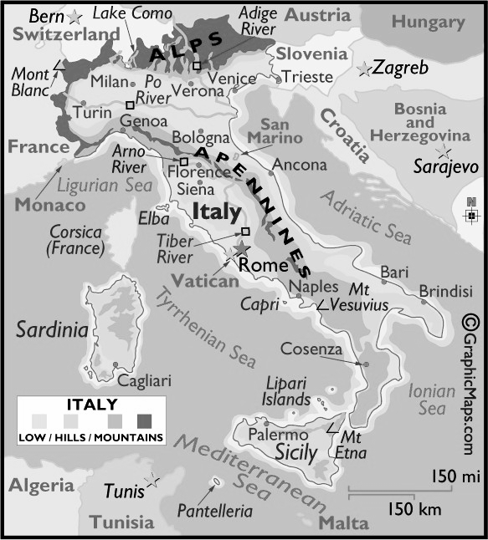
Part #2: COMPARING GEOGRAPHY
Directions: Fill in the chart to compare how the geography of ROME was DIFFERENT & SIMILAR to GREECE:
Ancient Rome | BOTH [HAVE IN COMMON] | Ancient Greece

Part #3: Close Reading Strategies & Comparison Chart
Directions: Check off as you complete each step.
- 1st: Read the paragraph and highlight key ideas with your teaM. discuss big ideas AND annotate each paragraph
- 2ND. Use the information to fill in the chart below.
WHY DID PEOPLE SETTLE IN ROME?
Historians have determined that Rome began as a collection of small towns located on seven hills near the shore of the Tiber River in Italy around 753 BCE. Rome is located in the center of modern-day Italy on a peninsula, which is a piece of land surrounded by water on three sides. This peninsula stretches into the Mediterranean Sea. Rome’s location offered several advantages. One of the advantages provided by the Italian peninsula was the protection offered by the hills and mountains found throughout the region.

NATURAL BENEFITS
Two major mountain chains found in Italy had a significant impact on the development of ancient Rome. The Alps, Europe’s highest mountains, separated the Italian peninsula from the rest of the continent. The Apennine Mountains run north to south along the length of the Italian peninsula. The Apennine Mountains made it difficult for people to cross from one side of the peninsula to the other. These two mountain chains helped to protect Rome from outside attacks. The seven hills of Rome were also used to protect the city.

THE CLIMATE EFFECTS ON ROME
The climate of central Italy, where the city of Rome was located, also helped the people of Rome. The region had mild, rainy winters and hot, dry summers. This climate made it possible for the region to develop a strong agricultural base. The mild climate enabled Romans to grow wheat, grapes, and olives and build a consistent food supply. This food supply supported the people and allowed Rome to prosper.While the climate made year-long farming possible, Rome was also strengthened by close access to water. The growing agricultural system was aided by the presence of the nearby Tiber River. Along with supporting Rome’s farmers, the Tiber River also provided several other benefits to ancient Rome

Part #4: Physical Features Impact on ROME
Directions: Use the chart to explain how each physical impacted the development.
- Use the annotations from your map to help you fill in the chart
Physical Feature Name | How Did It HELP the  Development of ROME | How Did It Make The Development of ROIME DIFFICULT
ITALIAN PENINSULA
Seas
Islands
Mountains
RIVERS
FOLD & GLUE

