ANCIENT GREECE GEOGRAPHY BLENDSPACE

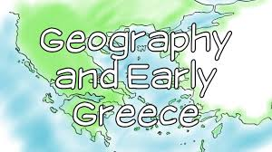
Directions: Check off each step as you complete them to make sure you do not miss a step.
- Use the link below to take you to Blendspace.
- Watch the 3 videos on Ancient Greece’s geography and collect 3 facts for each video.
- After collecting facts for each video make one connection to past civilizations we have studied (pick any of the following: Mesopotamia, Egypt, Indus).

Link: Greece Geography Blendspace

VIDEO ORDER | FACTS:  As you watch the video collect 3 important facts for each video. The facts you collect will help you with the quiz at the end of the Blendspace. | CONNECTION:  How is the Geography of Ancient Greece similar and/or different than the River Valley Civilizations we have studied (Mesopotamia, Egypt, Indus)?
#1 |  | - Fact 1:
#2 |  | - Fact 2:
#3 |  | - Fact 3:
Fold & Glue

