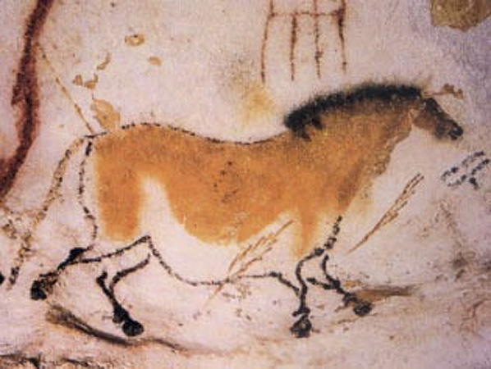
Prehistory First Name: ________________
Last Name:_________________
Core 1 2 3
Date: _________________

Detectives Who Study the Past
Archaeologists: Digging Up the Past
Archaeologists study the past by examining objects that people have left behind. These artifacts are anything made or used by people, such as clothing, tools, weapons, and coins. When archaeologists discover a place that has artifacts, they ask, Who lived in this place? When did they live? What were they like? Then they study the artifacts for clues.
Historians: Recording the Past
Historians are the recorders of the past. Human beings have been around a very long time. Historians are most interested in the last few thousand years, when people began leaving written record. The first question historians ask is, What happened in the past? To find out, they study all kinds of artifacts and documents. They read diaries and letters. Besides asking what happened, they try to understand why events happened the way they did.
Geographers: Mapping the Past
Geographers study natural features of the Earth, such as water, landforms, plants, and animals. They also look at human made features, such as towns, roads, bridges, and dams. They can help us answer questions like these: Where did people live? How did they use their environment to survive? Geographers often create maps to show what they have learned.
Archaeologists, historians, and geographers who study prehistoric history face a unique challenge because there is very little evidence from prehistoric times. There are huge gaps of time for which there is no evidence at all. This means that scientists can look at the same evidence and come up with different answers, or theories, about how humans came to be.

From Hunters and Gatherers to Farmers
Pre-Reading Directions: Answer the questions below in complete sentences.
1. What is a hunter-gatherer society?
2. What did ancient people gather?
3. Why did hunter-gatherer societies often have to move?
During Reading Directions: Find and box the following words in the reading below:
Hunter-Gatherers
Agriculture
Archaeologists
Civilization
Paleolithic Age
Neolithic Age
Domestication of Animals

Humans discovered farming toward the end of the Stone Age. The Stone Age gets its name from the tools people made of stone. It began with the first tool-making hominids about 2 million years ago. It lasted until around 3000 BC/BCE, when people learned to make tools and weapons out of metal.
Archaeologists, people who study artifacts from very distant past, divide the Stone Age into periods. The first is the Paleolithic Age, or Old Stone Age. During this time, people got their food by hunting wild animals and gathering nuts, berries, and other plants. They lived much of their lives out in the open and rarely stayed in one place for long.
By about 8000 BC/BCE, some groups of people had learned how to raise animals and crops for food. With this discovery, the Neolithic Age, or New Stone Age, began. For the first time, people settled down to live in one place.
The shift from being hunter-gatherers to being farmers is one of the most important advances people have ever made.
From Old Stone Age to New Stone Age
The Old Stone (Paleolithic) Age began about 2 million years ago and lasted until about 8000 BC/BCE. It was during this time that early modern humans developed. Like the hominids (human/ape like creatures) who came before them, early humans were hunter-gatherers. They wandered from place to place, looking for animals to hunt and plants to gather. Often they took shelter in caves, like the art that was found at the top of this page.
The New Stone (Neolithic) Age began when people learned to farm and produce their own food. The discovery of farming did not happen all at once. Over thousands of years, people gradually learned to raise animals and plant crops. Eventually they began to rely on farms for their food. Now they could settle down in one place instead of roaming in search of things to eat.
The Neolithic Age began around 8000 BC/BCE, and lasted until about 3000 BC/BCE, when people learned to make tools out of metal instead of stone. Farming developed in many parts of the world during this time, including parts of Europe, Africa, Asia, and the Americas.
Many Neolithic settlements were located east of the Mediterranean Sea, where the land was fertile (good for life, in this case, crops). Here, people built towns and villages.
People in settlements like these lived very different lives from earlier hunter-gatherers. With farms to provide their food, they could build permanent shelters and form larger communities. They could make better tools and clothing. And they could trade with people in other places for resources they wanted. They began to practice metallurgy, melting down rocks and turning them into metal. As you will see, these changes made life safer, more comfortable, and more interesting.

Creating a Stable Food Supply
During the Paleolithic Age, people obtained food by hunting animals and gathering plants. But hunting and gathering did not provide a very stable, or dependable, food supply. Wild plants and animals grew scarce when people stayed in one area for too long. And hunting was dangerous. Hunters were often injured or killed.
Gradually, people discovered they didn’t have to depend on hunting and gathering. Instead of gathering wild plants, they could plant seeds and harvest crops. Over time, they learned which seeds produced the most crops in the areas where they lived.
Early farmers also learned how to domesticate animals, raising and using them for their own purposes. They raised sheep, goats, and cattle for their meat. They got milk from both goats and cattle. They used mules to carry heavy loads and pull plows.
Together, the growing of crops and the domestication of animals are called agriculture. The Neolithic Age began with the invention of agriculture. For the first time, people had a stable food supply. This change led to the development of large, complex societies, called civilizations.
STUDENT FIRST AND LAST NAME: _______________________________ CORE 1 2 3
Post-Reading Questions:
ALL RESPONSES MUST BE IN COMPLETE SENTENCES. POINTS FOR GRAMMAR, SPELLING, PUNCTUATION, ETC. WILL BE DEDUCTED FROM THE TOTAL POINTS FOR EACH QUESTION.
- (Up to 10 pts.) What did you observe from your reading? ___________________________________________
- (Up to 15 pts.) Define:
  - Paleolithic Age: _____________________________________________________
  - Neolithic Age: _______________________________________________________
- (Up to 20 pts.) What logical predication can be made about the impact of hunter-gatherers on civilization? ______ _____________________________________
- (Up to 20 pts.) Explain the link between the Paleolithic and Neolithic Ages, in your own words. _________________
- (Up to 20 pts.) Based upon your reading, what conclusions can be drawn about how the Paleolithic and Neolithic Ages impact the world today? ________________________ ______
- (Up to 15 pts.) How would you differentiate between hunter-gatherers and agriculture? ______

