CHINESE DYNASTY #4→ HAN
Activity 1→ culture

VIDEO TO COLLECT EVIDENCE:
- Step #1: USE THE VIDEO LINK TO LEARN MORE ABOUT LIFE IN THE HAN DYNASTY
  - YOU ARE WATCHING TO LEARN ABOUT THE SILK ROAD, CIVIL SERVICE EXAM, & GOLDEN AGE
- Step #2: FILL IN 3 FACTS ABOUT EACH TOPIC. MAKE SURE YOU USE THE FACTS INCLUDE ON THE PRESENTATION TO GET THE MOST IMPORTANT DETAILS.
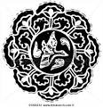
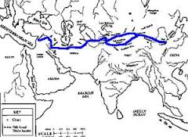
LIFE IN THE HAN DYNASTY
VIDEO→ CLICK HERE
Make sure you turn on “CC” and pause when needed to go at your own pace.
SILK ROAD | CIVIL SERVICE EXAM | GOLDEN AGE
FACT #1 | FACT #1 | FACT #1
FACT #2 | FACT #2 | FACT #2
FACT #3 | FACT #3 | FACT #3

AFTER ACTIVITY →FIND YOUR evidence sheet. Use the evidence from the passage above that you highlighted to complete the “HAN CULTURE QUESTION” on your paper.

Activity 2→ HISTORY

INVESTIGATING FOR RESEARCH:
- Step #1: USE THE LINK TO FIND ONE FACT FOR EACH SOCIAL GROUP. MAKE SURE YOU FACT EXPLAIN THE RESPONSIBILITY OF THAT SOCIAL GROUP
  - use this link to research about each group: CLICK HERE

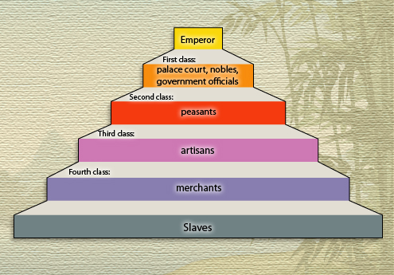 | 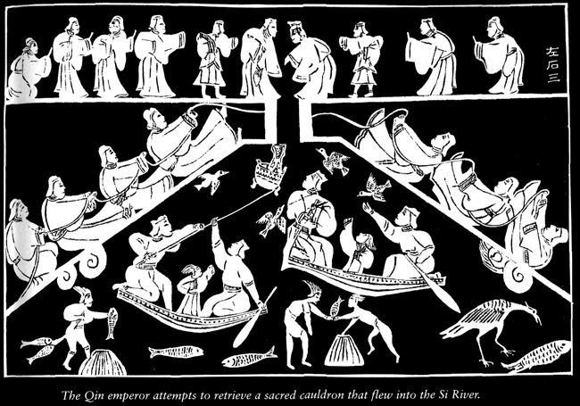

SOCIAL GROUP | RESPONSIBILITIES
- Emperor
- Nobles
- Peasants
- Artisans
- Merchants
- Slaves
How does this social hierarchy compare to other river valley civilizations? Do you agree with the Han social pyramid?

AFTER ACTIVITY →FIND YOUR evidence sheet. Use the evidence from the passage above that you highlighted to complete the “HAN HISTORY QUESTION” on your paper.

Activity 3→ government

PICTURE ANALYSIS:
- Step #1: LOOK AT PICTURE OF THE QIN THEN OF THE HAN DYNASTIES
- Step #2: ANSWER THE OBSERVATION QUESTION

QIN DYNASTY TERRITORY | HAN DYNASTY TERRITORY
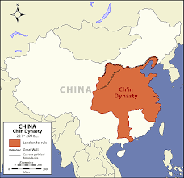 | 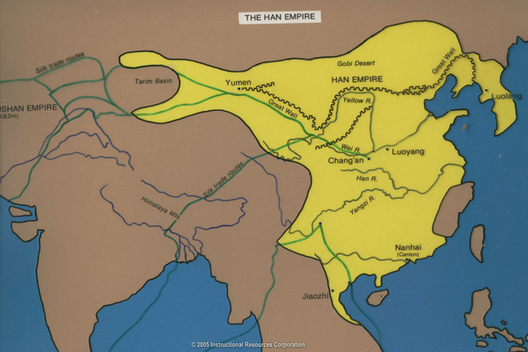
OBSERVATION QUESTION:  WHAT DO YOU NOTICE ABOUT THE SIZE OF THE QIN DYNASTY COMPARED TO THE HAN DYNASTY? | OBSERVATION ANSWER:

READING TO COLLECT EVIDENCE:
- Step #1: READ THE PASSAGE ABOUT THE LEADER OF THE HAN DYNASTY.
- Step #2: ANSWER CHECK FOR UNDERSTANDING QUESTIONS
- Step #3: TAKE THE SURVEY TO SEE WHAT JOB YOU WOULD BE GOOD AT! SHARE WITH YOUR TEACHER!

In 206 BCE, Liu Bang, who had led the revolt against the Qin, founded the Han dynasty. Like the Qin dynasty, the Han dynasty formed a strong central government. The emperors of the Han dynasty that came after Liu Bang were strong leaders, especially the emperor Wudi.

In 141 BCE, Wudi gained the throne and soon began to strengthen the armies and take aggressive actions to protect his empire. Instead of focusing on defending the kingdom, he attacked China’s enemies and helped expand China’s territory.

Emperor Wudi made Confucianism the state philosophy, which strongly influenced Han government and society. Confucianism emphasized moral responsibility and appointing government officials based on their virtue. Since Wudi placed great emphasis on education, he created Civil Service exams that would test a person’s knowledge and qualify them for a particular job. This system of promotion or leadership was based on ability, not birth.

Question | Answer
Who was leader during the majority of the Han Dynasty?
How did the government of the Han Dynasty compare to the Qin Dynasty?
What steps did Emperor Wudi do in order to expand the Han dynasty?
What was declared the philosophy of China during the Han dynasty?
How did this philosophy impact the society?
Why is a civil service exam important?
How does the idea of a person’s job based on ability not birth DIFFER FROM the caste system of India?
Do you think Emperor Wudi was an effective leader? Why or why not?
MODERN CONNECTION: Complete a quick survey to see what job YOU would be great at TODAY. Share your results with your TEACHER.
Link: CLICK HERE

AFTER ACTIVITY →FIND YOUR evidence sheet. Use the evidence from the passage above that you highlighted to complete the “HAN GOVERNMENT QUESTION” on your paper.

DID YOU FILL IN YOUR PAPER FOR DYNASTY 4 → HAN?
Great job! HIT TURN IN GOOGLE CLASSROOM!
YOU HAVE LEARNED ABOUT ALL THE CHINESE DYNASTIES!

CREATE A 20 QUESTION KAHOOT & SHARE WITH YOUR TEACHER
(5 QUESTIONS PER DYNASTY)

