ICE AGE AFFECTS THE EARLY HUMANS READING
Directions: Read the passage to learn more about how climate change impacted life for early humans.

Highlight the Text  In each paragraph highlight key information and facts that will help you understand and answer the questions. | Mark the Text:  Choose ONE to complete: Can be different for each box  - Write 3 WORDS in the box to summarize the information provided.  - Draw PICTURES next to each paragraph  - Write QUESTIONS/CONNECTIONS in the box
During the last 2 million years the Earth has experienced four long periods of cold climate known as ice ages. During each ice age, the average temperatures around the world have dropped dramatically. While the middle latitudes near the equator stay warm, the higher latitudes both in the North, and in the South get very cold, making life in these regions more difficult.
During an ice age period, massive glaciers form, this can cover thousands of square miles. As ice sheets spread across the landscape they freeze out plants and animals. As more and more water freezes the sea level decreases by as much as 300 feet. As sea levels drop, land bridges appear between continents and islands.
Due to changing climate patterns, people began to migrate (or move) to new places. When the sea levels dropped during the ice ages, one major land bridge developed between Asia and North America. This “land bridge” allowed for early humans to travel from Asia into North America. Today it does not exist and the water there is called the Bering Strait.
In new lands, early people had to learn to adapt to their new environments. They created clothing from animal skins, built new kinds of shelters and made new kinds of tools.

ICE AGE AFFECTS THE EARLY HUMANS QUESTIONS
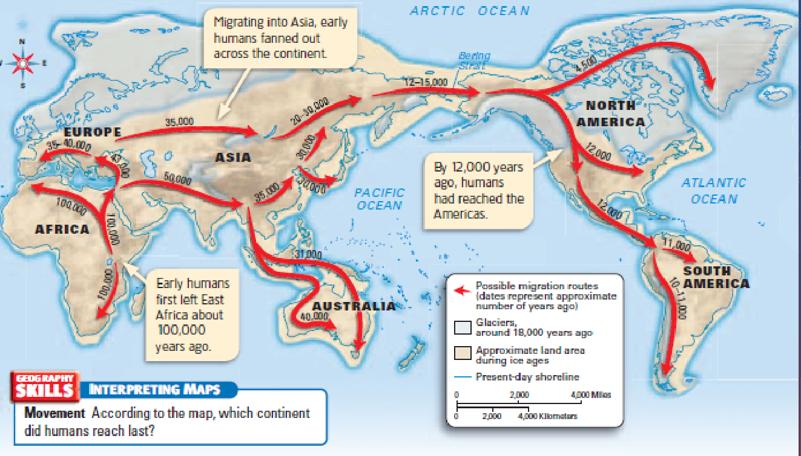
Map analysis Directions: To answer the questions, use the map below. Highlight and mark on the map.
1. Using the map key, what do the arrows stand for?
2. Which 2 bodies of water are between Asia and North America?
3. How long ago did early humans leave east africa?
4. Find the start of early humans. Place a large dot there.
- Which continent did early humans begin on?
5. Following the arrows: Place a large square there.
- Which continent did early humans reach last

matching Directions: use the reading about the Ice Age and early human migration, to match the vocabulary word below to the definition.
6. _______ Bering Strait | A. a section of land that acts as a bridge
7. _______ Migration | B. to adjust or get use to
8. _______ Land Bridge | C. a period of freezing
9._______ Adapt | D. the waterway between Alaska and Asia
10._______ Ice age | E. to travel or move
FOLD & GLUE

