NAME: ________________________ DATE:_________________ BLOCK:__________
Where Did The World Religions BEGIN?
CULTURAL HEARTH OF THE WORLD RELIGIONS

DIRECTIONS: Use the video to pinpoint the spot where each of the major world religions started! Color the map below at that spot. Follow the color the video is using and make sure you MATCH it to the KEY. As you watch this video focus only on where is STARTS for this section and color the region is STARTED ONLY. [We will focus on the spread next]
VIDEO LINK: CLICK HERE
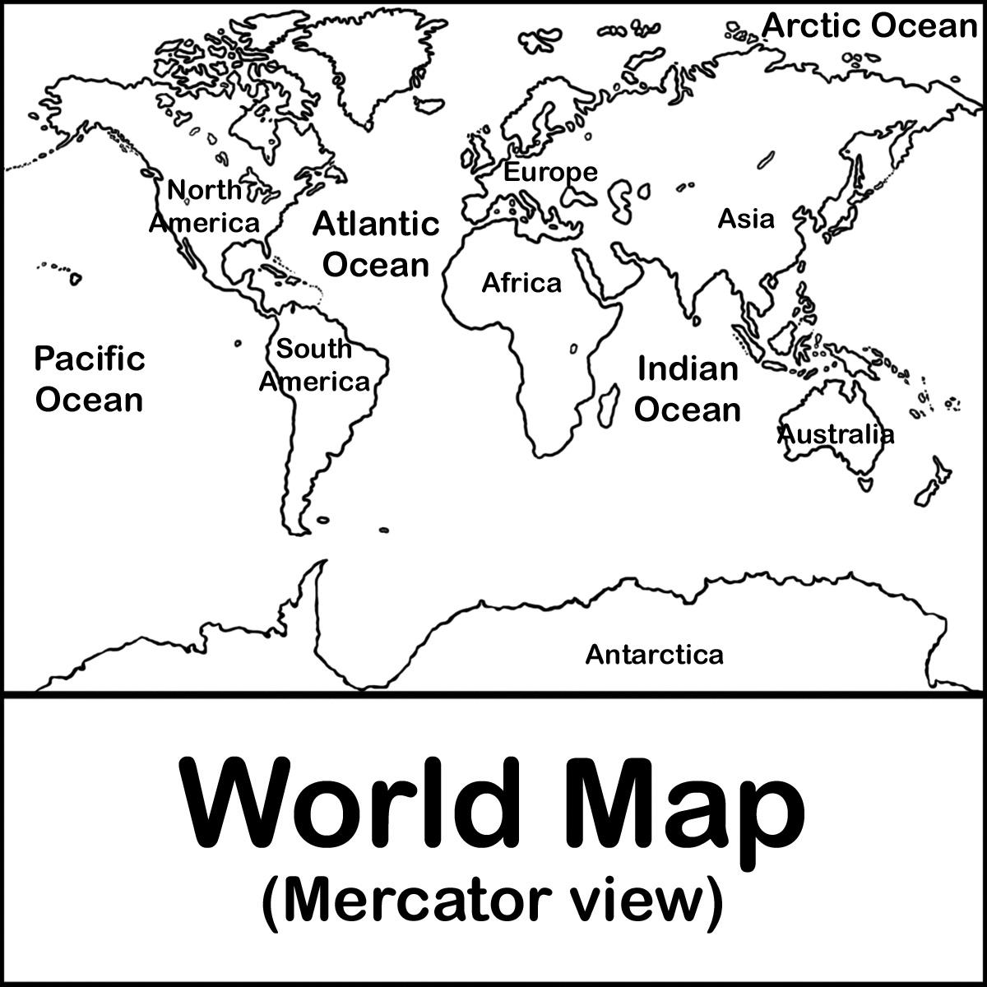

Christianity[Blue] Islam[Green] Hinduism [Orange]

Buddhism [Red] Judaism [Pink]

Where Did The World Religions SPREAD?
CULTURAL DIFFUSION OF THE WORLD RELIGIONS
Directions: Use the map on site using the link provided. This time you watch I want you to focus on where the religions spread to and color your map to represent where the religions are today. Make sure you MATCH it to the KEY as you color the map. Pause as you need to, or use fast forward to the end and pause.
- Having trouble with the video? Use the map on pg R38 and R39 in the green book under your desk.
VIDEO LINK: CLICK HERE

Christianity[Blue] Islam[Green] Hinduism [Orange]

Buddhism [Red] Judaism [Pink]
Reflection Question: Based on the map you colored, which religion became the most popular? Why do you think this happened? [ Answer in 2-3 sentences]
Fold and Glue

