Trading in Mesopotamia

How did farmers learn the secrets of trading?
Trade and commerce developed in Mesopotamia because the farmers learned how to irrigate their land. They could now grow more food than they could eat. They used the surplus to trade for goods and services. Ur, a city-state in Sumer, was a major center for commerce and trade. Temples were the chief employer and location for commercial activity.

What if you needed some important things. How could you get them?
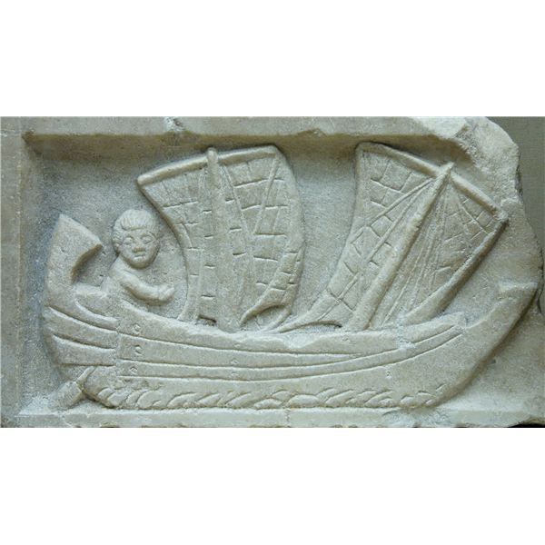
The system of trade developed from people's need. People in the mountains needed wheat and barley. Mountain people could give timber, limestone, gold, silver, and copper. Flax was grown in the river valley and then woven into cloth. Linen garments were worn by priests and holy men. Wool and wool cloth was also important for trade. Wood was used for ships and furniture.
Imagine having to take your boat apart after traveling down a river. Read on to find out why these people had to do this. The Tigris and Euphrates rivers made transport of goods easy and economical. Riverboats were used to transport goods for trade. Strong currents moved the boats downstream, but because of the current they could travel in one direction only. The boats had to be dismantled after the trip downstream.

Getting From Place to Place
The Mesopotamians were clever people and used interesting types of boats. The Mesopotamians used three types of boats: wooden boats with a triangular sail, the turnip or Guffa boat which was shaped like a tub, made of reeds and covered with skin, and the kalakku which was a raft of timbers supported by inflated animal skins. The invention of the wheel by the Sumerians revolutionalized the transportation. Wagons could be used to carry heavy loads.
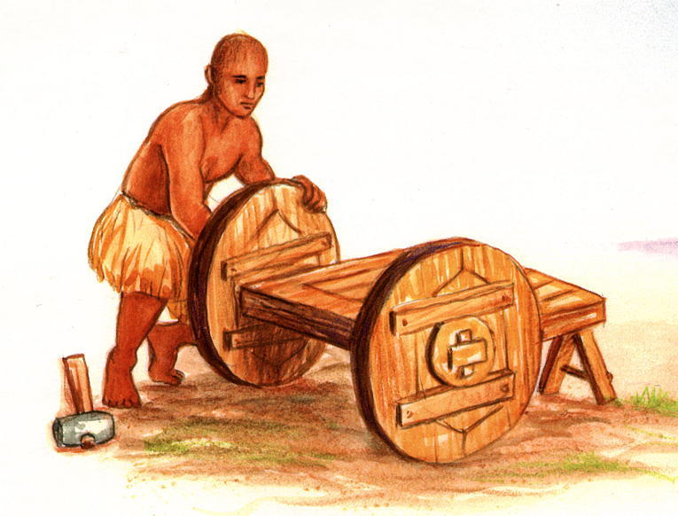
If you lived back then, you would not need money to get things you needed. Money wasn't used to trade goods and services. The Mesopotamians used the barter system instead. They developed a writing system to keep track of buying and selling. Scribes kept accurate records of business transactions by writing on clay tablets. Business contracts were sealed with a cylinder wheel.

