MIGRATION PLAYLIST DIRECTIONS
YOU WILL FOLLOW THIS PLAYLIST (CHECKLIST) TO COMPLETE EACH ACTIVITY. ALL THE MATERIALS YOU NEED WILL BE PROVIDED. WHEN YOU FINISH EACH ACTIVITY, CHECK IN WITH YOUR TEACHER TO SHOW THE ACTIVITY & GET INITIALED.
ACTIVITY | DIRECTIONS FOR ACTIVITIES  You will have to open drawings and type in the box provided | TEACHER INITIAL
[Visual Learning]  MIGRATION PUSH/PULL  T-CHART | For this activity you will use the Push/Pull t-chart paper provided to place the factors into the correct category.  - Define Push and Pull Factors  - Use the t-chart below to organize your words into the correct categories.  - Decide if they are examples of PUSH FACTORS or PULL FACTORS.  - After you sort the examples, come up with THREE other examples for each side  - Write your examples on the correct side
[Auditory Learning]  VOLUNTARY  VS  INVOLUNTARY MIGRATION | For this activity you will use the VOLUNTARY vs INVOLUNTARY MIGRATION paper provided to place the factors into the correct category.  - Read the each paragraph below.  - Highlight key information & write down your group's ideas in the box.  - CIRCLE/UNDERLINE EXAMPLES OF VOLUNTARY MIGRATION IN GREEN  - CIRCLE/UNDERLINE EXAMPLES OF INVOLUNTARY MIGRATION IN RED  - HIGHLIGHT THE DEFINITION OF VOLUNTARY & INVOLUNTARY MIGRATION  - Fill in the evidence chart.
[Kinesthetic Learning]  “Would You Rather” Real Life Scenarios | For this activity you will use examples posted around the hallway/room to fill in your “Would You Rather” Graphic Organizer.  - You have been given different scenarios to read.  - You will each decide if you would “stay” or “leave” your country.  - Write down your pros/cons on the graphic organizer provided and then decide what you would do.  - When your group is done, move to the next to the new scenario.
CONGRATS!  YOU DID IT! | Congratulations you have completed your Playlist!  Check in with your teacher by showing her this completed Playlist. Get the matching cards are complete to get the fastest time.

Pull Factor Definition:

________________________________________________________________________________________________________________________________

Push Factor Definition:

________________________________________________________________________________________________________________________________

Examples of Pull Factors From
Immigrant’s Story:

___________________________________
___________________________________
___________________________________
___________________________________

Examples of Push Factors From
Immigrant’s Story:

___________________________________
___________________________________
___________________________________
___________________________________

In which country do you believe he lives?
____________________________________________

Explain why you selected that country.
____________________________________________

Put yourself in the shoes of the character in the cartoon and complete the following sentence starter. If I were the character in the cartoon, I would . . . __________________________________________________________________________________ because… ________________________________________________

Describe 3 things you see in the cartoon.

___________________________________
___________________________________
___________________________________

Describe the how the character feels in the cartoon. ___________________________________

Why do you think he feels this way?
____________________________________________________________________________________________________________________________________________________________

Immigrant Story
My name is Dominik Zieba. I was born in Krakow, Poland in 1983 but most of my childhood I
lived in a village called Czarna Tarnowska. I was born into a very poor family and we did not
have much. While I was growing up in Poland, most of my family had already moved to
America and my mother was applying for a visa so our entire family could come to the United States.
While we were waiting for our approval or disapproval, we did what we could to manage. By “we” I mean my parents, they broke their backs to put food on the table every day. My dad walked two miles every morning to work because we did not have a car. Some people in our village owned a car, but we did not. While the economy and the corrupted Polish government were making it difficult for low income families to find jobs and food, Poland was still a beautiful place. There was no crime in the village; me, my friends and my 11 year old sister would play in the woods, our sandbox, or just simply walk around all hours in the night and no one minded. Poland at the time was still very safe, poor but safe. We were poor, but we were not unlucky because many children and families had it a lot worse so we felt blessed by God.
When I turned nine years old our visa had finally been approved and my dad, mom, sister, and I jetted off to America. We lived in my grandma’s house for 2 years while my parents cleaned houses and offices to earn money for an apartment. Eventually we got an apartment and my family started saving for a townhouse. After we got our town house my family started saving up for a single family home. They climbed the ladder of the American Dream as they now live in a house with a fence and three cars. We went from a village in Poland where we didn’t even own a couch to me living on my own and my parents living on their own.
When I graduated high school and began to appreciate what this country had given me, I registered to vote. I took an active role in my community because I now have my own son and a family and I do not wish for me and my son, what my dad and my mom went through. I keep my eyes on the news at all times and pay attention to the current events of this world, which will no doubt affect my son. America, this land, does not give out free handouts. My parents worked their butt off and they are the proof that hard work in this country does pay off.

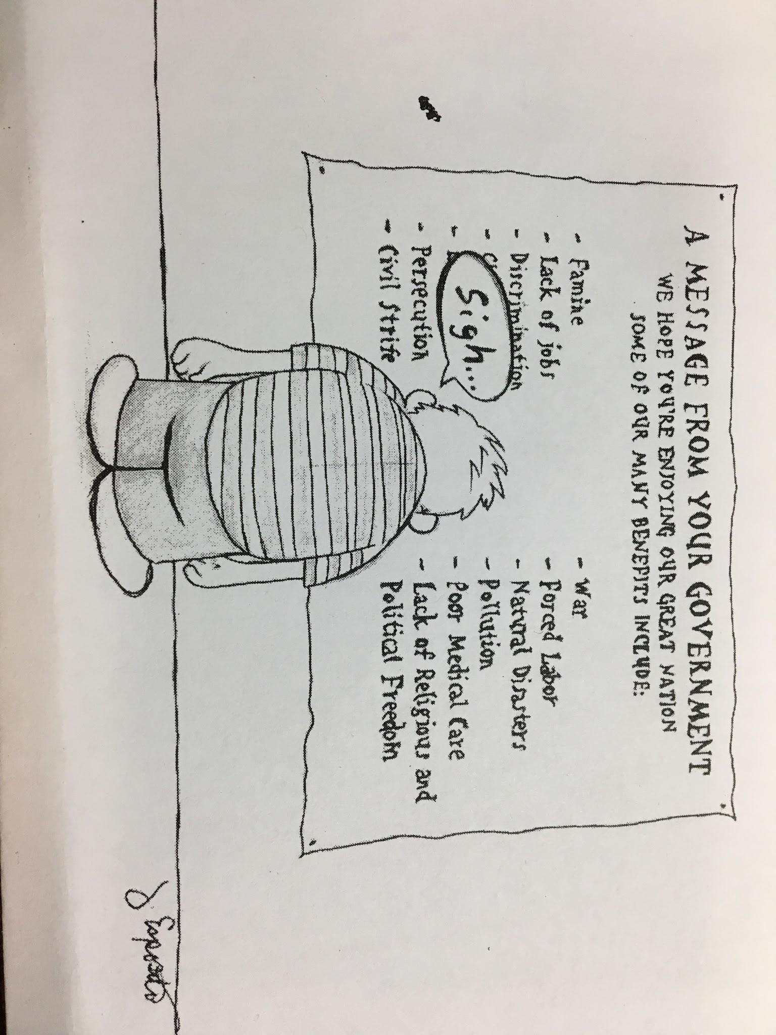

Push-Pull T-CHART
Directions: Create a T chart; half of the chart is for PUSH FACTORS and the other half is for PULL FACTORS. Put the following terms and place into the correct category. Come up with THREE other words for each side and write them on the correct side
Freedom Poor Economy
Overcrowding Jobs
Education Wars
Resources Lack of jobs and housing

Push Factors
Pull Factors
Overcrowding

VOLUNTARY & INVOLUNTARY MIGRATION
What is the difference between voluntary and involuntary migration?

DIRECTIONS:
- Take turns to read the each paragraph below.
- Highlight key information & write down your group's ideas in the box.
  - CIRCLE/UNDERLINE EXAMPLES OF VOLUNTARY MIGRATION IN GREEN
  - CIRCLE/UNDERLINE EXAMPLES OF INVOLUNTARY MIGRATION IN RED
  - HIGHLIGHT THE DEFINITION OF VOLUNTARY & INVOLUNTARY MIGRATION
- Fill in the evidence chart together as a team.

VOLUNTARY MIGRATION → GREEN
Some people migrate because they want to; others are forced to. Voluntary migration occurs when people choose to migrate of their own free will. During the 1800s, many Europeans willingly left their homelands to come to the United States. In the 1840s alone, some 1.4 million European emigrants left Europe to settle in the United States. Many of these people came from Ireland, where a potato crop failure resulted in one of the worst famines in history. Hunger and poverty were common push factors behind the voluntary migrations of this period. While Europeans may have felt that hardships at home gave them no choice but to leave, these people made their own decisions to seek a better life elsewhere.
Another example of voluntary migration is the Great Migration that took place in the United States from about 1915 until 1970. The Great Migration was a mass movement of about 6 million African Americans from the rural South to urban areas in the North. This population left to escape poverty and discrimination, or unfair treatment, based on the color of their skin and the legacy of slavery. In the South, African Americans had few economic opportunities and little chance of getting ahead. Those who left as part of the Great Migration went in search of better jobs, better quality of life, and more equal treatment.

Voluntary Migration Evidence Chart
Definition:

Example #1 | Picture
Example #2 | Picture
Example #3 | Picture

INVOLUNTARY MIGRATION → RED
Not everyone who migrates does so of his or her own free will. Involuntary migration is also known as forced migration because the people involved are forced to migrate, often under threat of death or violence. The transatlantic slave trade was one such example of involuntary migration. In fact, it is one of the largest involuntary migrations in human history. From the mid-1400s to around the late 1890s, between 12 million and 15 million men, women, and children in Africa were kidnapped and transported overseas as captives. The majority were taken to South, Central, and North America, where they were forced to work as slaves.
Today, large-scale involuntary migrations generally involve refugees fearing persecution rather than enslaved persons. Refugees are people who are forced to leave their native lands and are no longer protected by their former governments. In 2010, there were an estimated 15.4 million refugees living throughout the world.

Involuntary Migration Evidence Chart
Definition:

Example #1 | Picture
Example #2 | Picture
Example #3 | Picture

→?←Would You Rather PUSH & PULL SCENARIOS→?←

Directions:
- Your team is going to travel around the room to where you have been given different scenarios to read.
- You will each decide if you would “stay” or “leave” you country with your team.
- Write down your teams pros/cons on the graphic organizer provided and then vote what you would do.
- When your group is done, move to the next spot to read and discuss your new scenario.

Scenario # | Pros [Pulls] | Cons [Pushes] | My Vote  [Check One]
1 |  |  | - STAY  - LEAVE
2 |  |  | - STAY  - LEAVE
3 |  |  | - STAY  - LEAVE
4 |  |  | - STAY  - LEAVE
5 |  |  | - STAY  - LEAVE
6 |  |  | - STAY  - LEAVE
7 |  |  | - STAY  - LEAVE
8 |  |  | - STAY  - LEAVE

