POPULATION PLAYLIST DIRECTIONS:
You will follow this playlist (checklist) to complete each activity. All the materials you need will be provided. When you finish, check in with your teacher to show a completed checklist.

Activity | Activity Directions | Check Here When Completed
[Visual Learning]  What Ignited The Population Explosion? | For this activity you will investigate how the population explosion impacted the world.  - Use the reading to complete as a team.  - Read the information.  - Highlight key information  - Make notes and annotations in the right margin  - Complete the questions on the right column together.
[Auditory Learning]  The 3 Types of Communities  Video  and  Foldable | For this activity you will watch a video about the 3 types of communities [urban, suburban, and rural] people live in. Use the video to answer questions in the foldable provided.  - Urban, Suburban, Rural Video:  - While watching the the video complete the foldable about each of the 3 types of communities  - Video Link: http://bit.ly/1PYf4Xf
[Kinesthetic Learning]  Population Factor Scavenger Hunt  Fill in Graphic Organizer | Use examples posted around the room to fill in your Population Factors That Influence Population Graphic Organizer.  - Factors of Population Scavenger Hunt:  - Fill in Population Factors That Influence Population Graphic Organizer  - Read the examples and look at the picture. Decide if it is an Environmental, Economic, or Political Factor.
Congratulations you have completed your Playlist! | Check in with your teacher by submitting this completed Playlist.

What Ignited the Population Explosion?
Paragraph 1  1. How long did it take for the world population to reach 500 million?  2. What do you think birth rates means?  3. What do you think death rates means?  4. What allowed the world population to stay stable?  Paragraph 2  1. What happened during the late 1700’s and 1800’s?  2. What inventions contributed to the world population reaching two billion?  Paragraph 3  1. Where did people move to?  2. Why did people stop having so many children?  3. What does “less developed” mean?  4. Where did the birth rate remain high? Why?  Paragraph 4  1. What do you think demographers study?  2. What is the predicted population in year 2050? | The population explosion has been very recent in the scope of human history. People lived on Earth for about three million years before the world population reached 500 million, around the year 1600. Until then, birth rates and death rates were about the same, keeping the population stable. People had many children, but a vast number of them died before age five. Without modern medicine, vaccines, and clean, healthy living conditions, many children did not survive common diseases.  Answers  1.  2.  3.  4.  The late 1700s and the 1800s was a time of great advancement in science and technology in Europe and North America. The Industrial Revolution produced many inventions that promoted longer life, such as improvements in farming, nutrition, medicine, and sanitation. By 1930, the world population had reached two billion.  Answers  1.  2.  As people moved to cities to live and work, families became smaller. It was no longer necessary to have many children to work on family farms in Europe and North America, and birth rates dropped in industrialized countries. By the mid-twentieth century, death rates throughout the rest of the world also began to drop as medical technologies spread across the globe. But, birth rates remained high in developing countries, since their economies still relied largely on farming. Families in these places still needed many children to work the land. Although population growth  slowed in developed countries, the “population explosion” continued in the less developed world.  Answers:  1.  2.  3.  4.  In 1960, the global population reached three billion. Just 15 years later, in 1975, the population soared to four billion and it topped five billion in 1987. In 1999, the Earth became home to six billion people, and the population had doubled in less than 40 years. Although population growth is now slowing, the population is expected to reach seven billion by late 2011, and demographers predict that the world will grow by two to three billion more people by the year 2050.  Answers:  1.  2.

3 Types of communities
Use the video link to answer the questions about life in an Urban, Rural, and Suburban location.
https://youtu.be/GuF2o7SaRWU
- What does urban have to do with?  - What are urban characteristics?  - Urban areas have a population of what?  - How do urban areas use their land?  - Why do people live in apartment buildings?  - What kind of transportation is used in an urban area? | 1.  2.  3.  4.  5.  6.
- What does suburban mean?  - What are the characteristics of a suburban area?  - What is the population of suburban areas?  - Where do most people live in the suburban area?  - How is land used in the suburban areas?  - How do people get to the urban area from the suburban area? | 1.  2.  3.  4.  5.  6.
- What do people think of when talking about a rural area?  - What does rural mean?  - What are the characteristics of a rural area?  - What is the population of rural areas?  - What do people do with all of the space in a rural area?  - What kind of transportation do people in rural areas use? | 1.  2.  3.  4.  5.  6.

Factors That Influence Population
SCAVENGER HUNT

Directions: Fill in the graphic organizer below. Read each example. The example provided will fit into one of the three categories. Write the Title of the example under the correct column.
Environmental [Land] | Economic [Money] | Political [Government]
Access to Water | Jobs

JOBS
IS IT EASY OR HARD TO FIND JOBS TO MAKE MONEY?
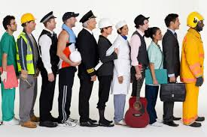

Access to Water
IS THERE FRESHWATER OR OCEAN IN THE AREA?
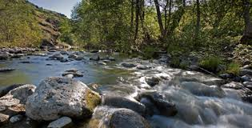
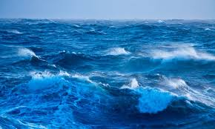

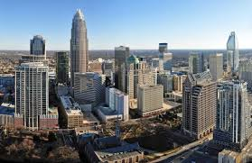
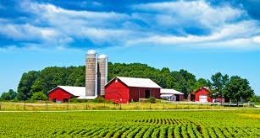
types of communities

HOW MUCH LAND IS THERE IN THE AREA?: URBAN, SUBURBAN RURAL, AREAS

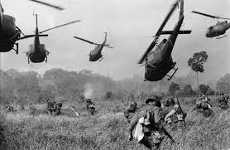
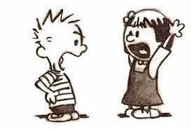
wARS & CONFLICTS

IS GOVERNMENT PROTECTING THE PEOPLE? IS IT SAFE TO LIVE THERE?
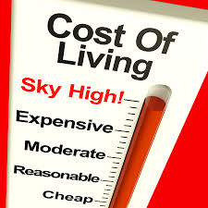
price of goods

ARE THINGS TOO EXPENSIVE TO LIVE THERE?

tYPE OF ECONOMY

HOW ARE BUSINESSES CONTROLLED. WHO SAYS WHAT THE PRICE OF GOODS ARE?

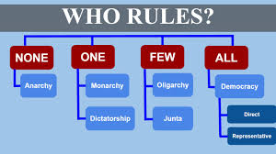
tYPE OF GOVERNMENT

DO PEOPLE HAVE FREEDOM OR IS EVERYTHING CONTROLLED BY GOVERNMENT?

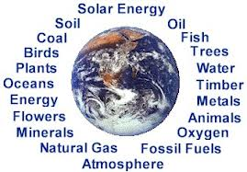
NATURAL RESOURCES
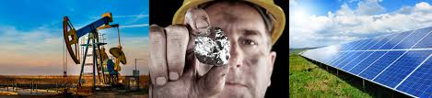

WHAT RESOURCES ARE THERE IN THE AREA? [OIL, CROPS, TIMBER, WATER]
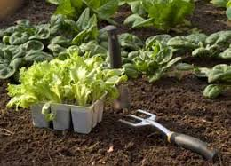
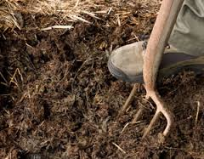
FERTILE LAND

DOES THE LAND ALLOW PEOPLE TO GROW CROPS THERE?

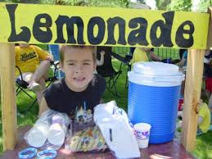
ABILITY FOR PEOPLE TO EARN MONEY

ARE THERE ENOUGH JOBS FOR EVERYONE TO EARN MONEY?
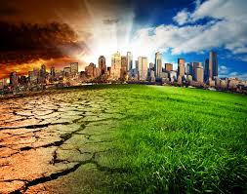
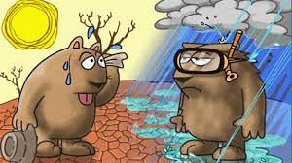
CLIMATE

IS THE CLIMATE GOOD OR BAD FOR LIVING AND GROWING CROPS?

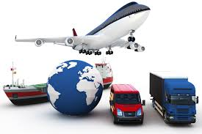
TRANSPORTATION
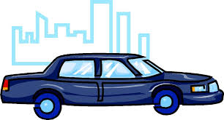

ARE THERE ROADS, HIGHWAYS, AIRPORTS THAT MAKE IT EASY FOR PEOPLE, GOODS, AND IDEAS TO MOVE IN THE AREA?

