Unit 9 Monotheism Guided Notes
Name___________________  Date: 2/___/17  Unit: _________ | World Religions: ________________
Followers & Founders of World Religions  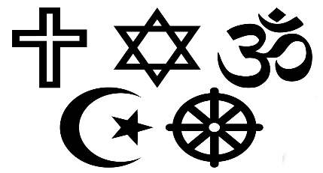  What is a Religion?  2 Types of Religions  WHICH CAME FIRST?  Judaism  →_________________  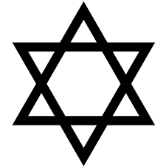  Christianity  →_________________  Islam  →_________________  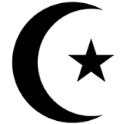  Hinduism  →_________________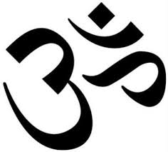  Buddhism  →_________________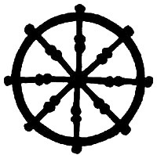 | Religion Followers FOUNDER  Judaism 14.5 million ABRAHAM  2 Billion JESUS CHRIST  Islam 1.1 billion  Buddhism 362 Million THE BUDDHA  820 Million NO FOUNDER  - A religion is an _______________ system of ____________, ceremonies, and rules to worship a_________ or a group of _______________.  - _______________ religions believe in one god.  - _______________ religions believe in many gods.  - _____ World religion → Judaism  - _____ World religion → Christianity  - _____ World religion → Islam  - Name of deity is _______________ (God in Hebrew)  - _______________ is the founder of Judaism.  - Followers of Judaism are called _______________  - Follow the rules of the _________ commandments.  - The Star of David is the symbol for Judaism.  - Their holy book the _______________.  - Is a long scroll hand-written in Hebrew → (traditional Jewish language).  - Leaders are called _______________  - Name of deity is _______________  - Christianity was influenced by _______________.  - Founder is _______________→ the son of God  - Follow the rules of the _______________commandments.  - Their holy book the Holy _______________.  - Followers are called Christians  - The Christian symbol is the cross.  - Leaders are called _______________, ministers, monks, and nuns  - Name of deity is _______________ (God in Islam)  - _______________ founded the religion  - Their holy book the _______________.  - The Islamic symbol is the crescent moon and star.  - Followers are called _______________.  - Leaders are called Ulama and Imam→ lead prayers  - Follow the 5 _______________ of faith to guide their life.  - Hinduism is the world’s _______________ religion.  - There is ________ founder  - They do not have just one holy book→ ___________ is one example  - The symbol is the “AUM (OM)” symbol.  - Leaders are called ___________, holy man, Brahmin priest  - Hindus believe in _______________ and reincarnation  - They use _______________ to reach a peaceful state called nirvana  - The _______________ is the founder Buddhism.  - He was known as _______________ Gautama a prince before becoming Buddha  - Followers of buddhism are called Buddhist  - Follow the rules of the _______________ path to reach nirvana.  - The Wheel is the symbol.  - They do not have one holy book→ Dhammapada is one example  - Leaders are called _______________ and nuns
Reflection 2/___/17  How are monotheistic and polytheistic religions different?  (Must be 5 sentences) | ____________________________________________________________________________________________________________________________________________________________________________________________________________________________________________________________________________________________________________________________________________________________________________________________________________________________________________________________________________________________
FOLD & GLUE

